EXP: 02 FORMS USING ZOHO CREATOR
(STUDENT MANAGEMENT SYSTEM)

1. Introduction
The Student Management System is a database-driven application developed using Zoho Creator to manage and organize student-related information in a structured manner. The system provides a centralized platform for storing student personal details, academic records, guardian contact information, and course enrollment details.
Zoho Creator provides a low-code development environment that allows applications to be developed using forms, reports, and charts with minimal programming. In this project, different forms were created to collect and store information related to students. Reports were then generated to display the submitted records in a tabular format. A Pivot Chart was also created to provide a graphical representation of the academic data.
The application consists of four major modules: Student Profile, Academic Record, Guardian Contact, and Course Enrollment. Each module contains suitable fields for entering and managing the required information. These modules work together to provide an organized student management system.

2. Objectives
The main objective of this project is to develop a simple and efficient student management application using Zoho Creator. The system is designed to centralize student information and make it easier to enter, store, retrieve, and analyze data.
The specific objectives are to maintain student personal information, store academic records, manage guardian contact details, maintain course enrollment information, generate reports from submitted data, and represent selected information using charts. The system also aims to reduce manual record keeping and provide faster access to student information.

3. Student Profile Module
The Student Profile module is used to collect and maintain the basic details of students. The form contains fields such as full name, date of birth, gender, contact number, email address, enrollment status, academic year, program of study, and student status.
The form provides a structured interface for entering student information. After the details are entered, the user can submit the form, and the information is stored in the Zoho Creator database.
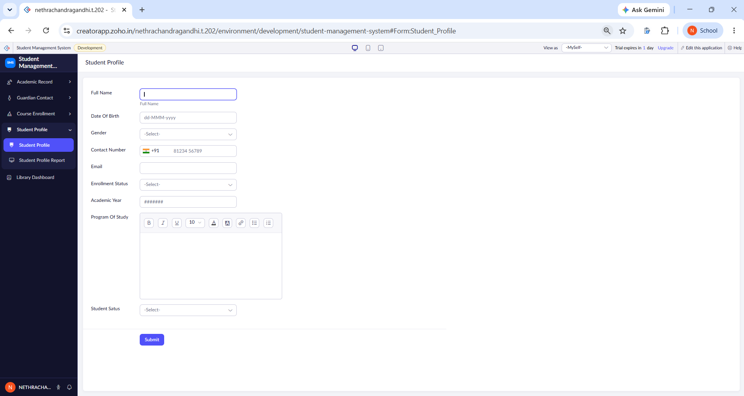
Figure 1: Student Profile Form
The submitted information can be viewed through the Student Profile Report. The report displays the stored information in a tabular format, allowing the administrator to easily view and manage student records.
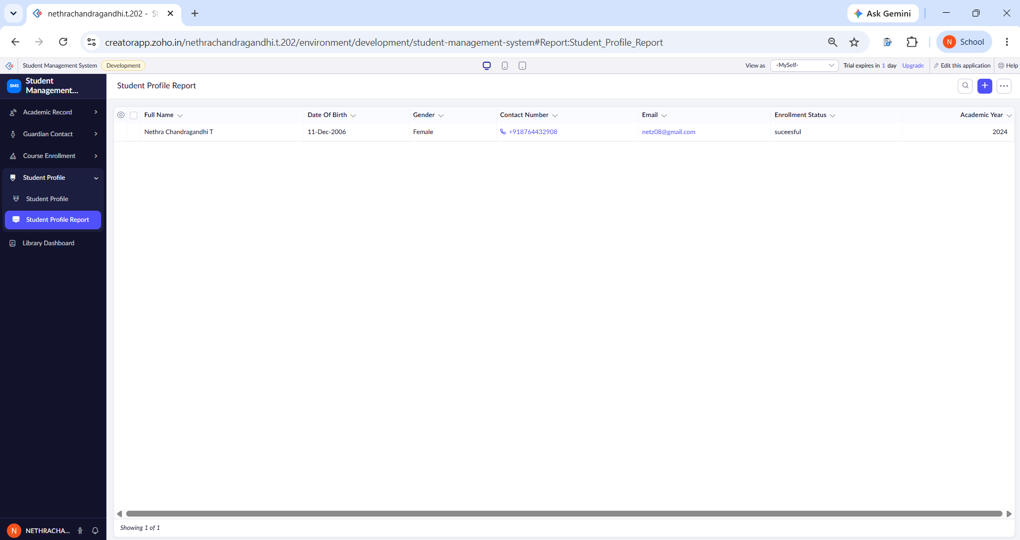
Figure 2: Student Profile Report
The Student Profile module therefore provides the basic identification and enrollment information required for managing student records.

4. Academic Record Module
The Academic Record module is used to maintain the academic information of students. The form contains fields including student name, program name, enrollment date, academic level, GPA, semester, course code, year of study, and status.
The student name is entered using the name fields, while the program name provides information about the student's course of study. The enrollment date records when the student joined the program. Academic level, GPA, semester, course code, and year of study provide information about the student's academic progress.
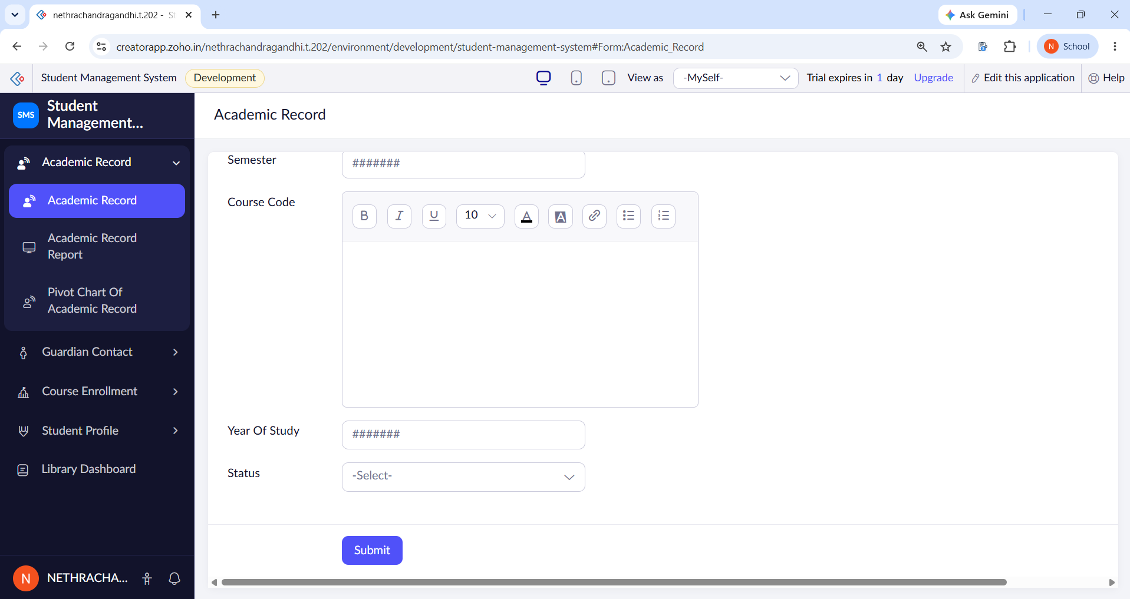
Figure 3: Academic Record Form
After submitting the academic information, the records are displayed through the Academic Record Report. The report provides a structured table containing the student name, program name, enrollment date, GPA, semester, course code, and academic level.
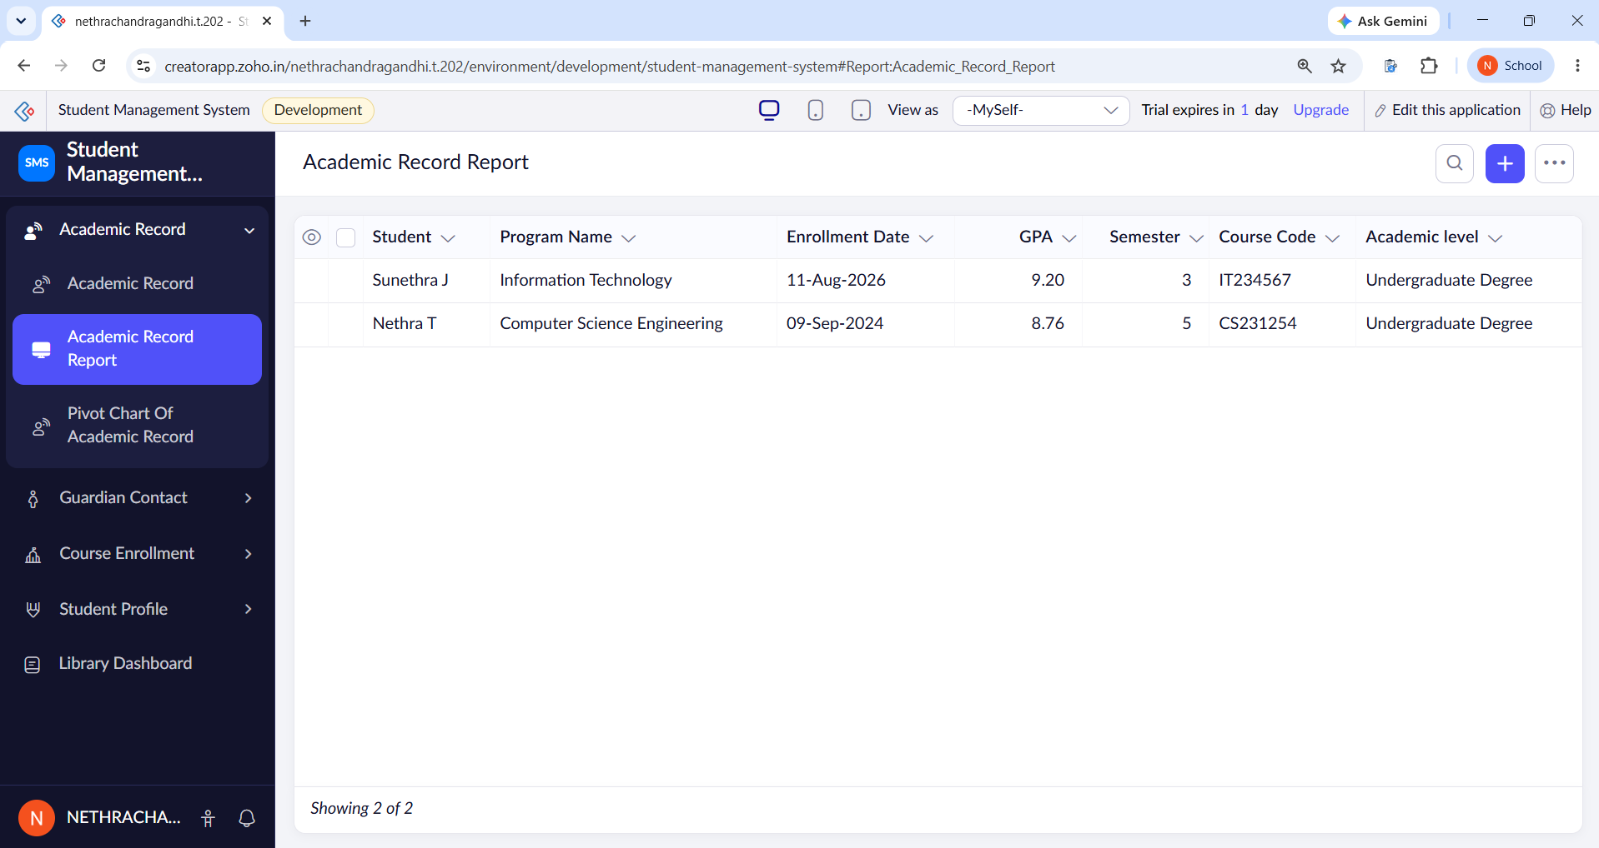
Figure 4: Academic Record Report
The report makes it easier to view multiple academic records in one place and provides a convenient way to access student academic information.

5. Pivot Chart of Academic Record
A Pivot Chart was created to provide a graphical representation of the academic records. The chart groups students based on their academic level and displays the corresponding student count.
In the created application, the chart displays the number of students under the Undergraduate Degree category. This provides a simple visual representation of the academic data stored in the application.
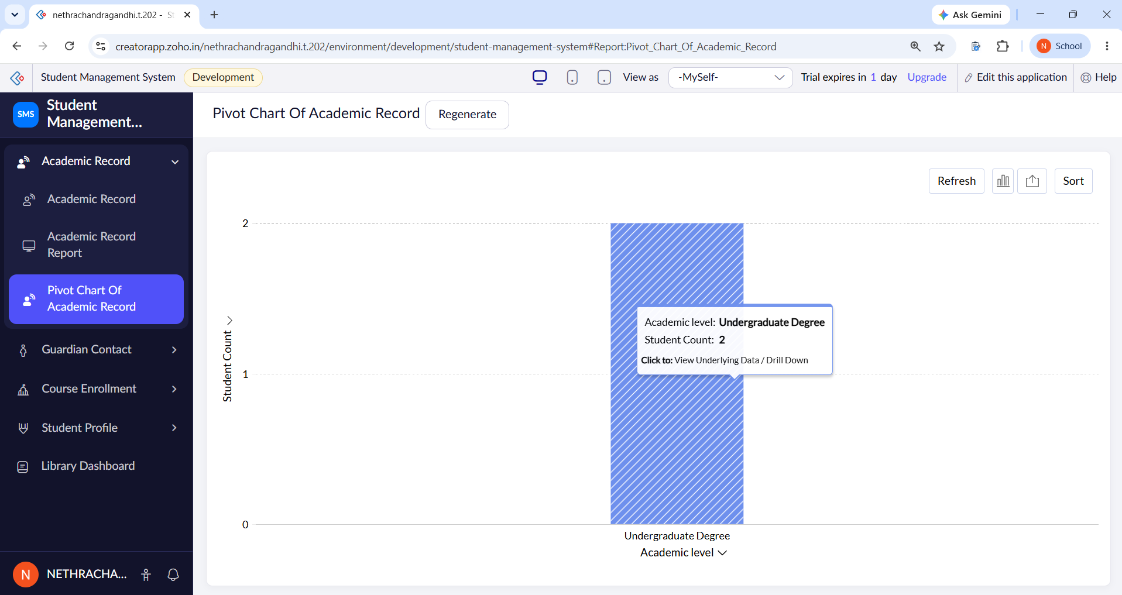
Figure 5: Pivot Chart of Academic Record
The Pivot Chart is useful because it provides a quick visual summary of the data. Instead of examining each individual record in the report, the administrator can use the chart to understand the distribution of students based on the selected category.

6. Guardian Contact Module
The Guardian Contact module is used to maintain the contact information of a student's guardian. The form includes fields such as student name, guardian name, relationship, phone number, email address, and residential address.
The relationship field identifies the guardian's relationship with the student, such as parent. The phone number and email fields provide communication details. The address section contains fields for address lines, city or district, state or province, postal code, and country.
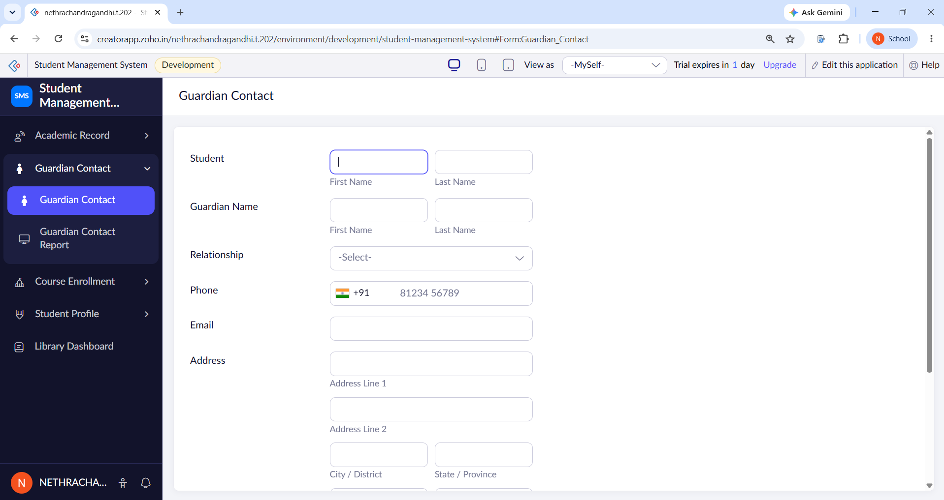
Figure 6: Guardian Contact Form
The form also contains an Emergency Contact option and a Preferred Contact Method field. These fields can be used to identify whether the guardian should be contacted during emergencies and to specify the preferred method of communication.After the form is submitted, the information is displayed through the Guardian Contact Report.
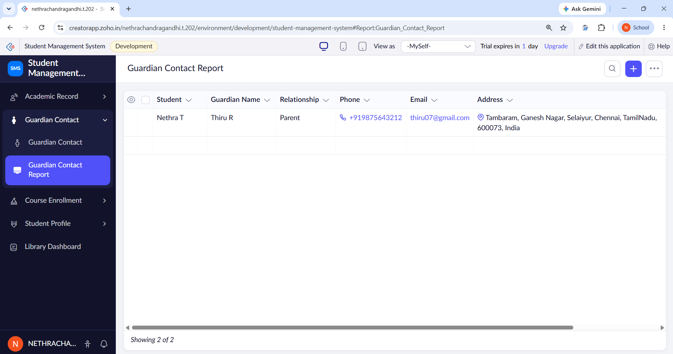Figure 8: Guardian Contact Report
The Guardian Contact Report displays important information such as the student name, guardian name, relationship, phone number, email address, and address. This provides administrators with quick access to guardian contact information whenever required.

7. Course Enrollment Module
The Course Enrollment module is used to maintain information about the courses taken by students. The form contains fields such as student name, course code, course name, semester, enrollment date, instructor name, credits, grade, and status.
The student name identifies the student who is enrolled in the course. The course code and course name identify the particular course. Semester and enrollment date provide information about when the course was taken, while instructor name identifies the faculty member responsible for the course.
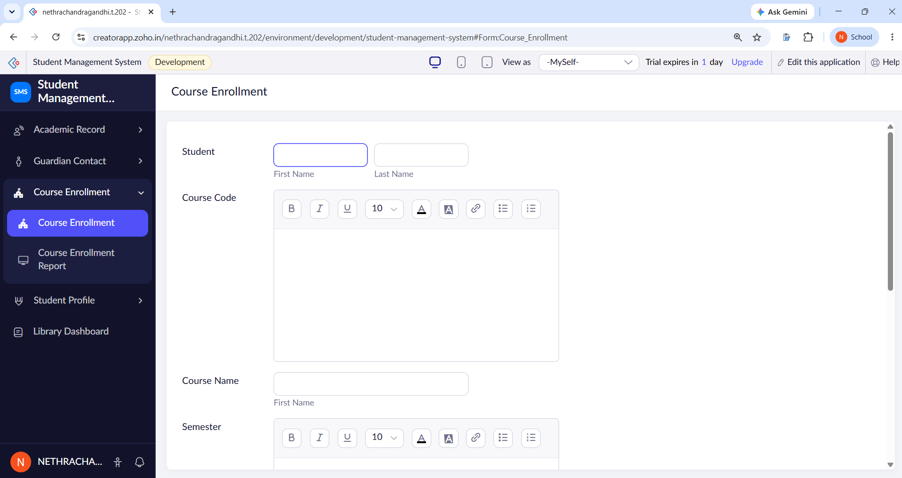Figure 9: Course Enrollment Form
The lower section of the form contains fields for enrollment date, instructor name, credits, grade, and status. Credits indicate the academic value of the course, while the grade field records the student's performance.
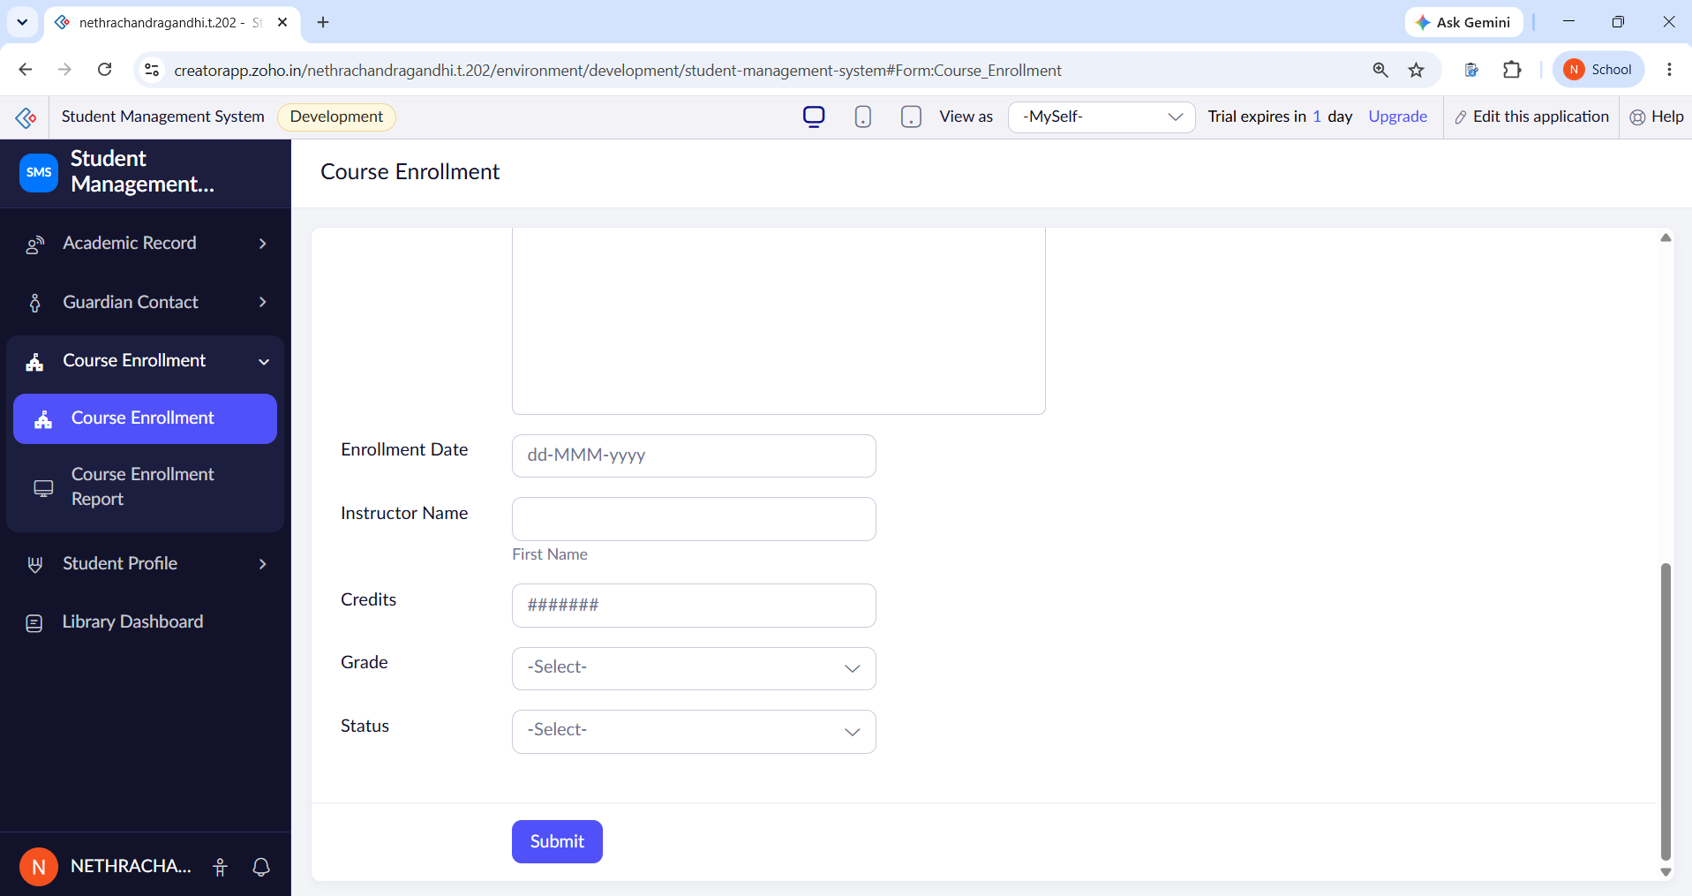Figure 10: Course Enrollment Form – Academic Details
Once the course enrollment information is submitted, it is displayed through the Course Enrollment Report. The report provides a structured view of the course information entered into the system.
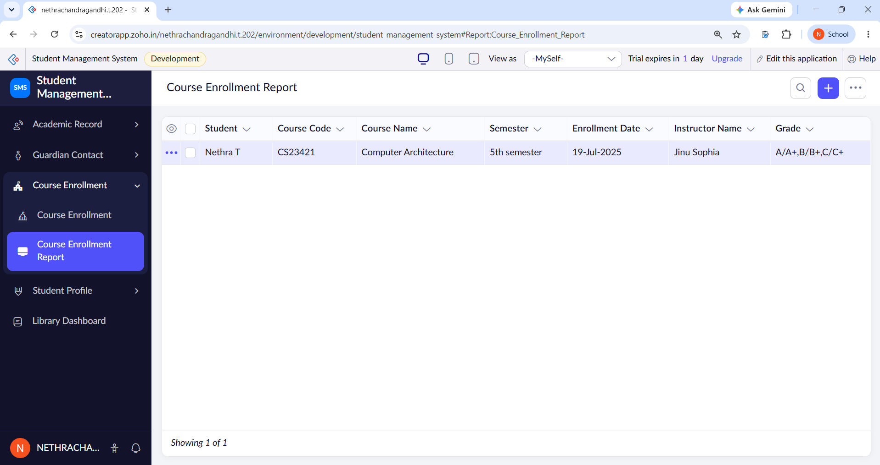Figure 11: Course Enrollment Report
The report displays information such as student name, course code, course name, semester, enrollment date, instructor name, and grade. This makes it easier to track the courses associated with a particular student.

8. Overall Working of the System
The Student Management System follows a simple data management process. First, the administrator enters the required information through the appropriate form. Once the form is submitted, the data is stored in the Zoho Creator application. Reports are then used to display the stored information in a structured format.
The overall workflow can be represented as:
Data Entry → Form Submission → Data Storage → Report Generation → Data Visualization
The Student Profile module manages personal information, the Academic Record module manages academic information, the Guardian Contact module manages guardian details, and the Course Enrollment module manages course-related information. The reports provide an organized view of the stored records, while the Pivot Chart provides a graphical representation of selected academic data.

9. Advantages of the System
The Student Management System provides several advantages. It provides centralized data management by keeping student information within a single application. The use of forms makes data entry simple and structured. Reports allow users to retrieve and view information quickly without manually searching through individual records.

10. Result
The Student Management System was successfully developed using Zoho Creator. The required forms were created for Student Profile, Academic Record, Guardian Contact, and Course Enrollment. The submitted information was successfully displayed through the corresponding reports.
The Academic Record module was also connected to a Pivot Chart to provide a graphical representation of student data. The project demonstrates how Zoho Creator can be used to create a structured low-code application for managing student information.

